**Programming Lab Exam revision**

**Question 1a**

a = 8;

b = 5;

c = 0;

c = a;

a = b;

b = c;

The value in a is the value in b is the value in c is

**Question 2a**

In one sentence describe the purpose of the following code; assume the variables have all been declared as integers with integer values.

num1 = 10; num2 = 2; num3 = 8;

if (num1 < num2)

{

Code to swap the values in num1 and num2 goes here

}

if (num2 < num3)

{

Code to swap the values in num2 and num3 goes here

}

if (num1 < num2)

{

Code to swap the values in num1 and num2 goes here

}

**Question 3a**

What does the following code produce?

for(int i=0;i<=2;i++)

{ for(int j=0;j<=i;j++)

{

Console.Write(“*”);

}

Console.WriteLine();

}

1. *** b) * c) *

*** ** *

*** *** *

**Question 4a**

What are the values in each variable after the following code has run:

int num1 = 6;

int num2 = 2;

int num3 = 10;

int num4 = 3;

int temp = 0;

temp = num1;

num1 = num4;

num4 = temp;

temp = num2;

num2 = num3;

num3 = temp;

The value in num1 is the value in num2 is the value in num3 is the value in num4 is ___ the value in temp is .

**Question 5a.**

What is the purpose or outcome of the following piece of code?

num1 = num2 + num1;

num2 = num1 – num2;

num1 = num1 – num2;

1. To find the sum of the values of num1 and num2
2. To find the difference of the values of num2 and num1
3. To find the sum and the difference of the values of num1 and num2
4. To swap the values of num1 and num2
5. Something else – please write the purpose

**Question 6a.**

In one sentence describe the purpose of the following three lines of code:

temp = num1;

num1 = num2;

num2 = temp;

1. Yahtzee- Fours: A player throws 5 dice, their score in the Fours category is 4 times the amount of fours they throw. So for a throw of 6,5,4,3,4, they get 8 points. Then a second player has a turn. Draw an activity diagram for the code below.

static void Main()

{

int Player1Score = 0, Player2Score = 0, fours = 0, dice = 0;

Random rand = new Random();

Console.WriteLine("Player One’s turn");

for (int i = 0; i < 5; i++)

{

dice = rand.Next(1, 7);

Console.WriteLine(dice);

if (dice == 4)

{

fours++;

}

}

Player1Score = fours * 4;

//resetting variable

Console.WriteLine("Player Two’s turn");

fours = 0;

for (int i = 0; i < 5; i++)

{

dice = rand.Next(1, 7);

Console.WriteLine(dice);

if (dice == 4)

{

fours++;

}

}

Player2Score = fours * 4;

Console.WriteLine("Player 1 scored {0}, Player 2 scored {1}", Player1Score, Player2Score);

Console.ReadLine();

}

1. Draw a diagram to plan a program that reads in a number of exam marks, the users tells the program how many marks there are. The program keeps a count of how many marks were over 80 and adds all the marks together to work out the average for that set.

For example, your program output would look something like this:

Exam Program

How many marks are you going to enter?

3

Please enter the marks, one per line

40

81

60

Thank you, here are the class results:

Number of marks: 3

Average mark: 60.33

Number of marks over 80: 1

Thank you for running the marks program

### Number Powers

Write out the code for a program that works out the powers of numbers using the diagram below as a guide. The user is asked for the base number and the power.

For example, for base 3 and power 5: 35 = 3*3*3*3*3 = 243

For base 2 and power 3: 23 = 2*2*2 = 8

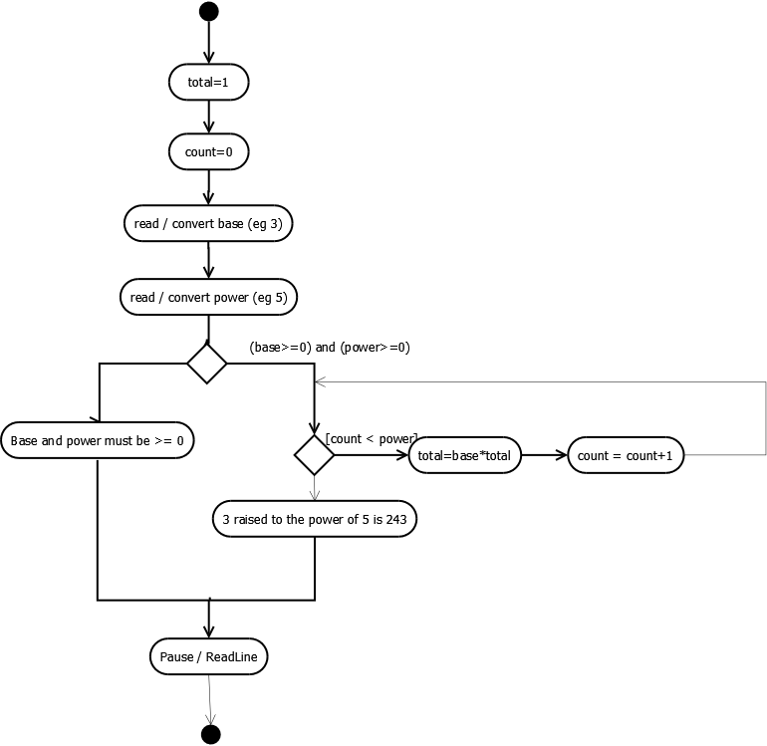

using System;

namespace NumberPowers

{

class Program

{

static void Main(string[] args)

{

}

}

}

1. Explain in one sentence the main purpose of this code. What do you think it’s doing? Do not explain the code line by line.

static void Main(string[] args)

{

string temp;

int check = 0;

int number;

Console.WriteLine("Please enter a number, enter stop to finish");

temp = Console.ReadLine();

while (temp != "stop")

{

number = Convert.ToInt32(temp);

if (number % 2 == 0)

{

check = check + 1;

}

Console.WriteLine("Please enter a number, enter stop to finish");

temp = Console.ReadLine();

}

Console.WriteLine("Check = " + check);

Console.ReadLine();

}

1. Explain in plain English the main purpose of this diagram. What do you think it’s doing? Do not explain the code line by line.

